**System Requirements and Design Document (SRD)**

**for**

**Transportation Management System**

**Document Version 1.3**

27 November 2012



Swave Incorporate Sdn. Bhd

No.21, 5th Floor, BlockMaju,

Dataran Dwitasik, Jalan Dwitasik J7/4,

Bandar Sri Permaisuri, 56000 Kuala Lumpur,

MALAYSIA

System Requirements and Document Transportation Management System

Version 0.3 ● 27 November 2012

**Revision History**

|  |  |  |  |
| --- | --- | --- | --- |
| **Name** | **Date** | **Reason for Change** | **Version** |
| Sanbron Liong Khing Tze | 27 Nov 2012 | Initial release of SRD | 1.1 |
| Sam Yin Yee | 10 Sept 2012 | Addition of Preamble Content and Appendices | 1.2 |
| Sam Yin Yee | 15 Oct 2012 | Minor updates to text and systems diagrams | 1.3 |

**TABLE OF CONTENTS**

|  |  |
| --- | --- |
| **1.0 Introduction** |  |
| **1.1 Objectives** |  |
| **1.2 Design Concept** |  |
| **1.3 Modules** |  |
| **1.4 Development Environment** |  |
|  |  |
| **2.0 Transport Management System Overview** |  |
| **2.1 Function** |  |
| **2.2 Modules Details** |  |
| **2.2.1 Home Screen** |  |
| **2.2.2 Administrator Login** |  |
| **2.2.3 Administrator Menu** |  |
| **2.2.4 Balance driver workload** |  |
| **2.2.5 Monitor Transport Maintenance** |  |
| **2.2.6 Customer and User Management** |  |
| **2.2.7 Reporting for Management Team** |  |
| **2.2.8 Transport Rental** |  |
| **2.3 System Flow Diagram** |  |
| **2.4 Use Case Diagram** |  |
| **2.5 Context Diagram** |  |
| **2.6 Data Flow Diagram** |  |
|  |  |
| **3.0 Conclusion** |  |
|  |  |
| **4.0 Appendix** |  |
| **4.1 System Interface** |  |

**1.0 Introduction**

This System Requirements and Design Document (SRD) describe the requirements for the Transport Management System for JPPH, Universiti Malaysia Pahang.

**1.1 Objectives Transport Management System**

The objectives of this system are:

1.1.1 To manage all the information and knowledge effectively by using a computerize system that collects all data to form a database system

1.1.2 To save administrator time in assigning drivers to each customer

1.1.3 To maintain a balance among all drivers

1.1.4 To operates and deliver rental receipt to customer online

1.1.5 To monitor the condition of every vehicle throughout the service.

1.1.6 To ensure customer are satisfied with the rental car

1.1.7 To create efficient workers that produce efficient work, productive results and rapid development across time.

**1.2 Design Concept**

Transport Management System was designed to create:

1.2.1 A User friendly interface for the customers’ and user who used this system.

1.2.2 A system that follows the international standards that have the functionality of renting cars, manage user and customer information and balancing the drivers workload.

1.2.3 A real time data manipulation that alters registers data from customer or user.

**1.3 Modules**

The following are the modules in the Transport Management System in Figure 1 :

1.3.1 Balance driver workload

1.3.2 Monitor Transport Maintenance

1.3.3 Customer and User Management

1.3.4 Reporting for Management Team

1.3.5 Transport Rental

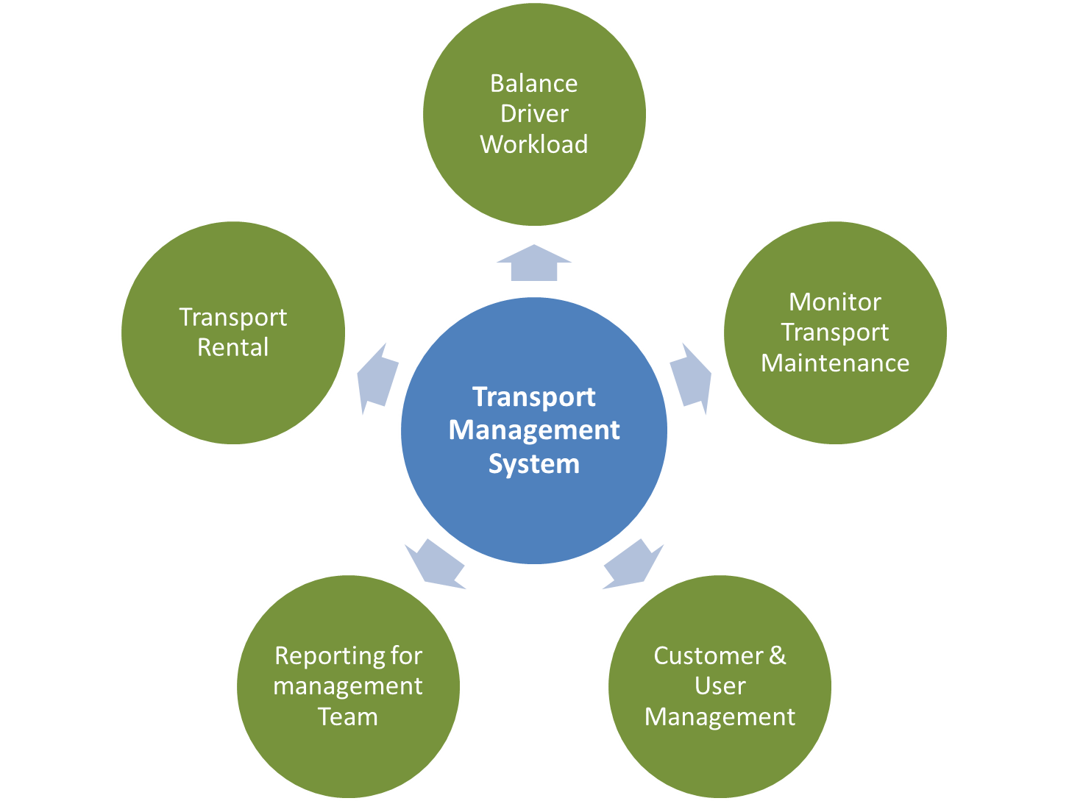

**Figure 1: Transport Management System Modules**

* 1. **Development Environment**

1. **Transport Management System Overview**

**2.1 Function**

The following are the functions of the Transport Management System:

2.1.1 To create a digital environment for the ease use of transport rental process and managing rentals in a more efficient way with an interactive navigation of user interface.

2.1.2 This system also has the feature of balancing the driver workload where all customers and drivers have equal chance to rent a transport.

2.1.3 Management team (admin) also able to monitor the rental process of the system and for maintenance of the vehicle so it is good throughout the service.

2.1.4 The management team also able to maintain the user id in the system by create, edit, viewing and delete the user id that registered by the user to the system.

2.1.5 This Transport Management System also can produce transport business report to the management team.

2.1.6 Customer or university’s staff user will be able to execute rental through this system and also create user account for themselves to the system.

**2.2 Modules Detail**

2.2.1 Home Screen **(Figure 2)**

**Figure 2** Shows the main screen at the start up. User will need to choose whether to login as admin (If user were one of the management team) or login as customer and ready. User also can register as new user from this screen.

2.2.2 Administrator Login **(Figure 3)**

**Figure 3** Shows the secure admin login as super user of the system. After login, admin will direct to the administrator menu screen.

2.2.3 Administrator Menu **(Figure 4)**

**Figure 4** Shows the administrator menu (Super user of system) that can be direct to the other module such as balance driver workload, monitor transport & maintenance, customer & user management and report.

2.2.4 Balance driver workload **(Figure 5)**

**Figure 5** Shows the screen of balancing the driver workload by system admin assign customer (driver) to specific available transport or automatically assign to random available transport. This function is important to prevent overload of customer rent the same vehicle.

2.2.5 Monitor Transport Maintenance **(Figure 6)**

**Figure 6** Shows the screen of monitoring the vehicle condition and maintenance. Admin or Management Team can add car maintenance for specific vehicle by filling up the required field. For the vehicle condition will show the current condition of the vehicle by selecting any one vehicle in list.

2.2.6 Customer and User Management **(Figure 7.1, Figure 7.2)**

**Figure 7.1** Shows the customer registration screen for university staff or student. Basically, users need to register their information to this system in order to rent an available vehicle. There are several information such as matric ID, name, password, phone number, address and hostel. This is important to compile into the vehicle renting report for the Management Team. Click register and the customer is registered and return to home screen.

**Figure 7.2** Shows the customer and user management screen for administrator. In this module, admin will be able to scroll throughout the registered customer and vehicle renter. Admin also able to add new user, update registered user, delete registered user and print report for the current user information. Admin will be direct to the report module for report display and printing.

2.2.7 Reporting for Management Team **(Figure 8)**

**Figure 8** Shows the module for transport business report. This module will display all the records of rental information from customer and car information. Only admin or management team can access this report module. This module consists of vehicle information, customer information, renting times, date, and maintenance history.

2.2.8 Transport Rental **(Figure 9.1, Figure 9.2)**

**Figure 9.1** Shows the module for customer to rent a vehicle. Customer will only need to choose the vehicle that they want to rent, type in matric ID, start time and end time. For the total time, it will calculate itself after customer type in the start and end time. Click on the RENT button and the customer will be registered to rent the selected vehicle.

**Figure 9.2** Shows the module for customer to purpose their vehicle for renting. User will need to enter their name, transport name and matric ID in order for the vehicle to register and available for other customer to rent it.

**3.0 Conclusion**

The overall system has 5 modules; Balance driver workload, Monitor Transport Maintenance, Customer and User Management, Reporting for Management Team, Transport Rental. Each module has their own data flow diagram and combines to make a case diagram. This system can be used for admin or customer. The flow of the system is explained at the system flow diagram. The design components is used as the guidelines for the system interface and based on the objectives of the system. The requirements of the system will be increasing and expanding from time to time. As such, the Transport Management System must be designed with high flexibility and expandability attributes.

**4.0 Appendix**

**4.1 System Interface**

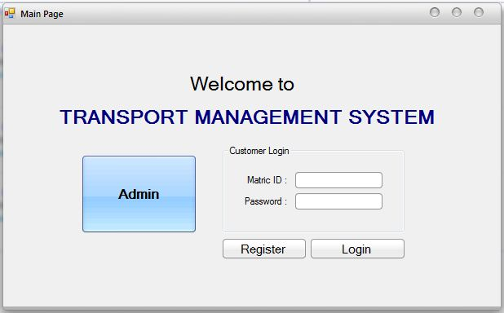

**Figure 2: Home screen**

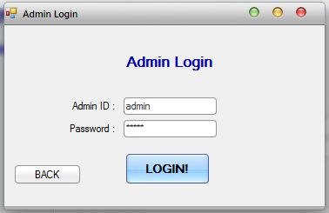

**Figure 3: Administrator Login**

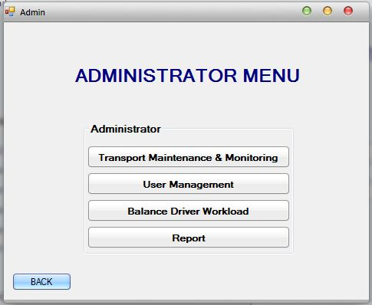

**Figure 4: Administrator Menu**

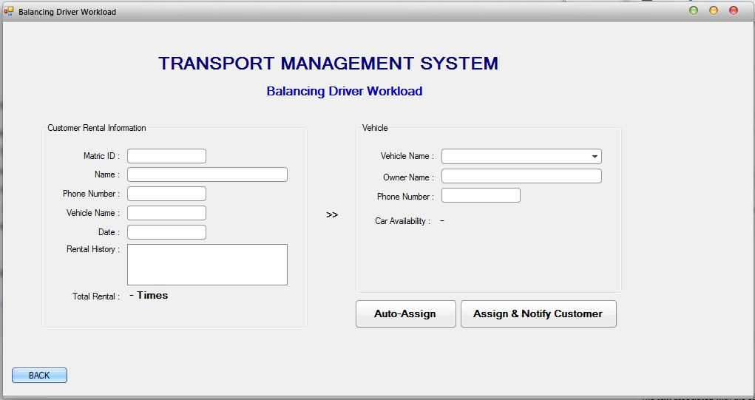

**Figure 5: Balancing Driver Workload**

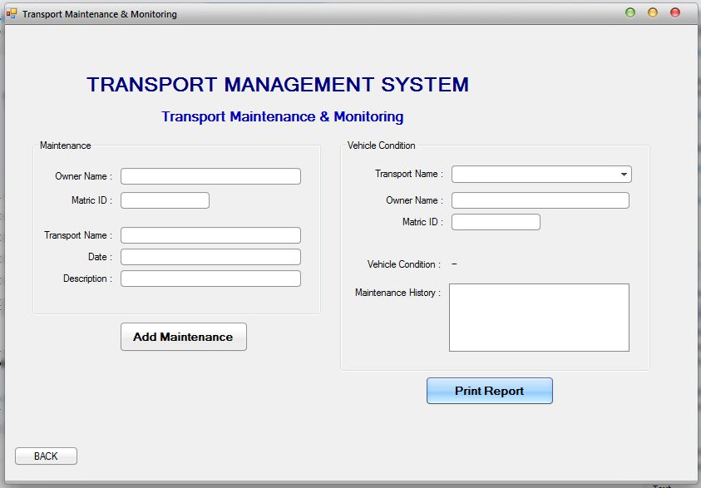

**Figure 6: Monitoring Transport Maintenance**

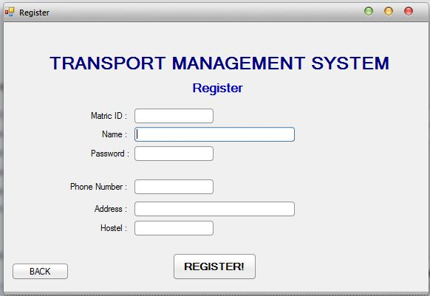

**Figure 7.1: Customer Registration**

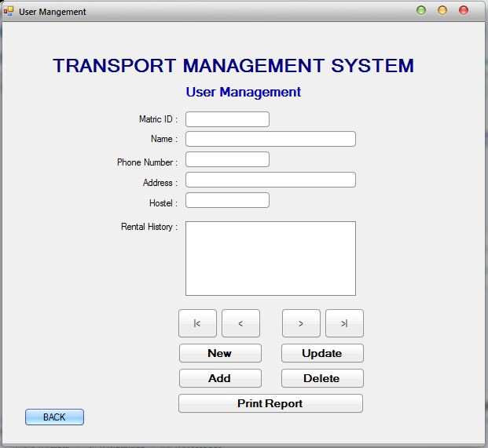

**Figure 7.2: User and Customer Management**

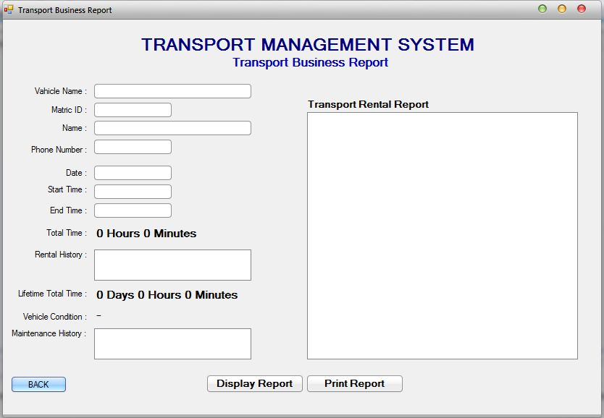

**Figure 8: Report for Management Team**

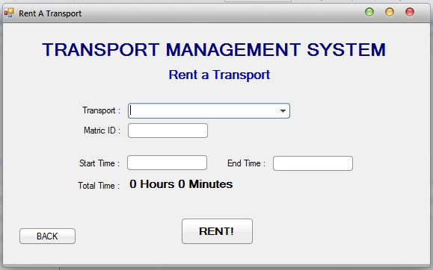

**Figure 9.1: Vehicle Rental**

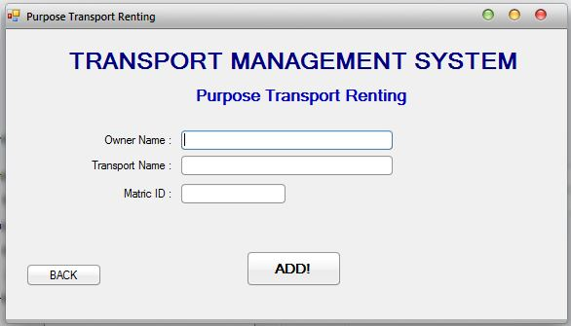

**Figure 9.2: Purpose Vehicle Rental**